 SUBMITTED BY: ZULQARNAIN HAIDER
REG #: SP24-BSE-179
SUBJECT: Data Structure Lab 2
SUBMITTED TO: Nauman khan
DATE: 10-09-2025
____________________________________________________________
Q1: Pizza Billing System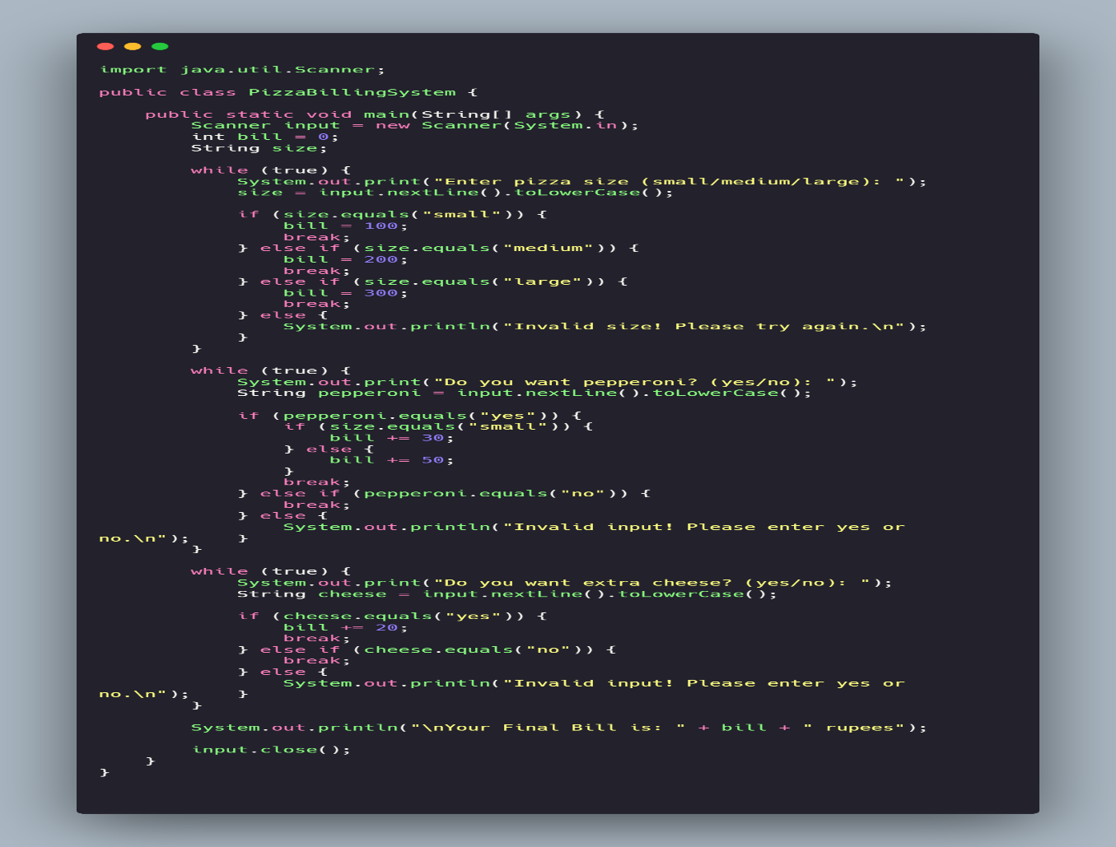
Output: 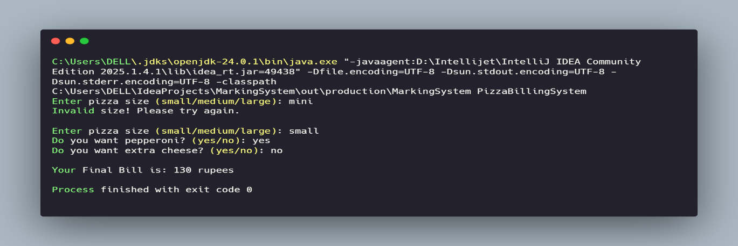
Q2: Array Analyzer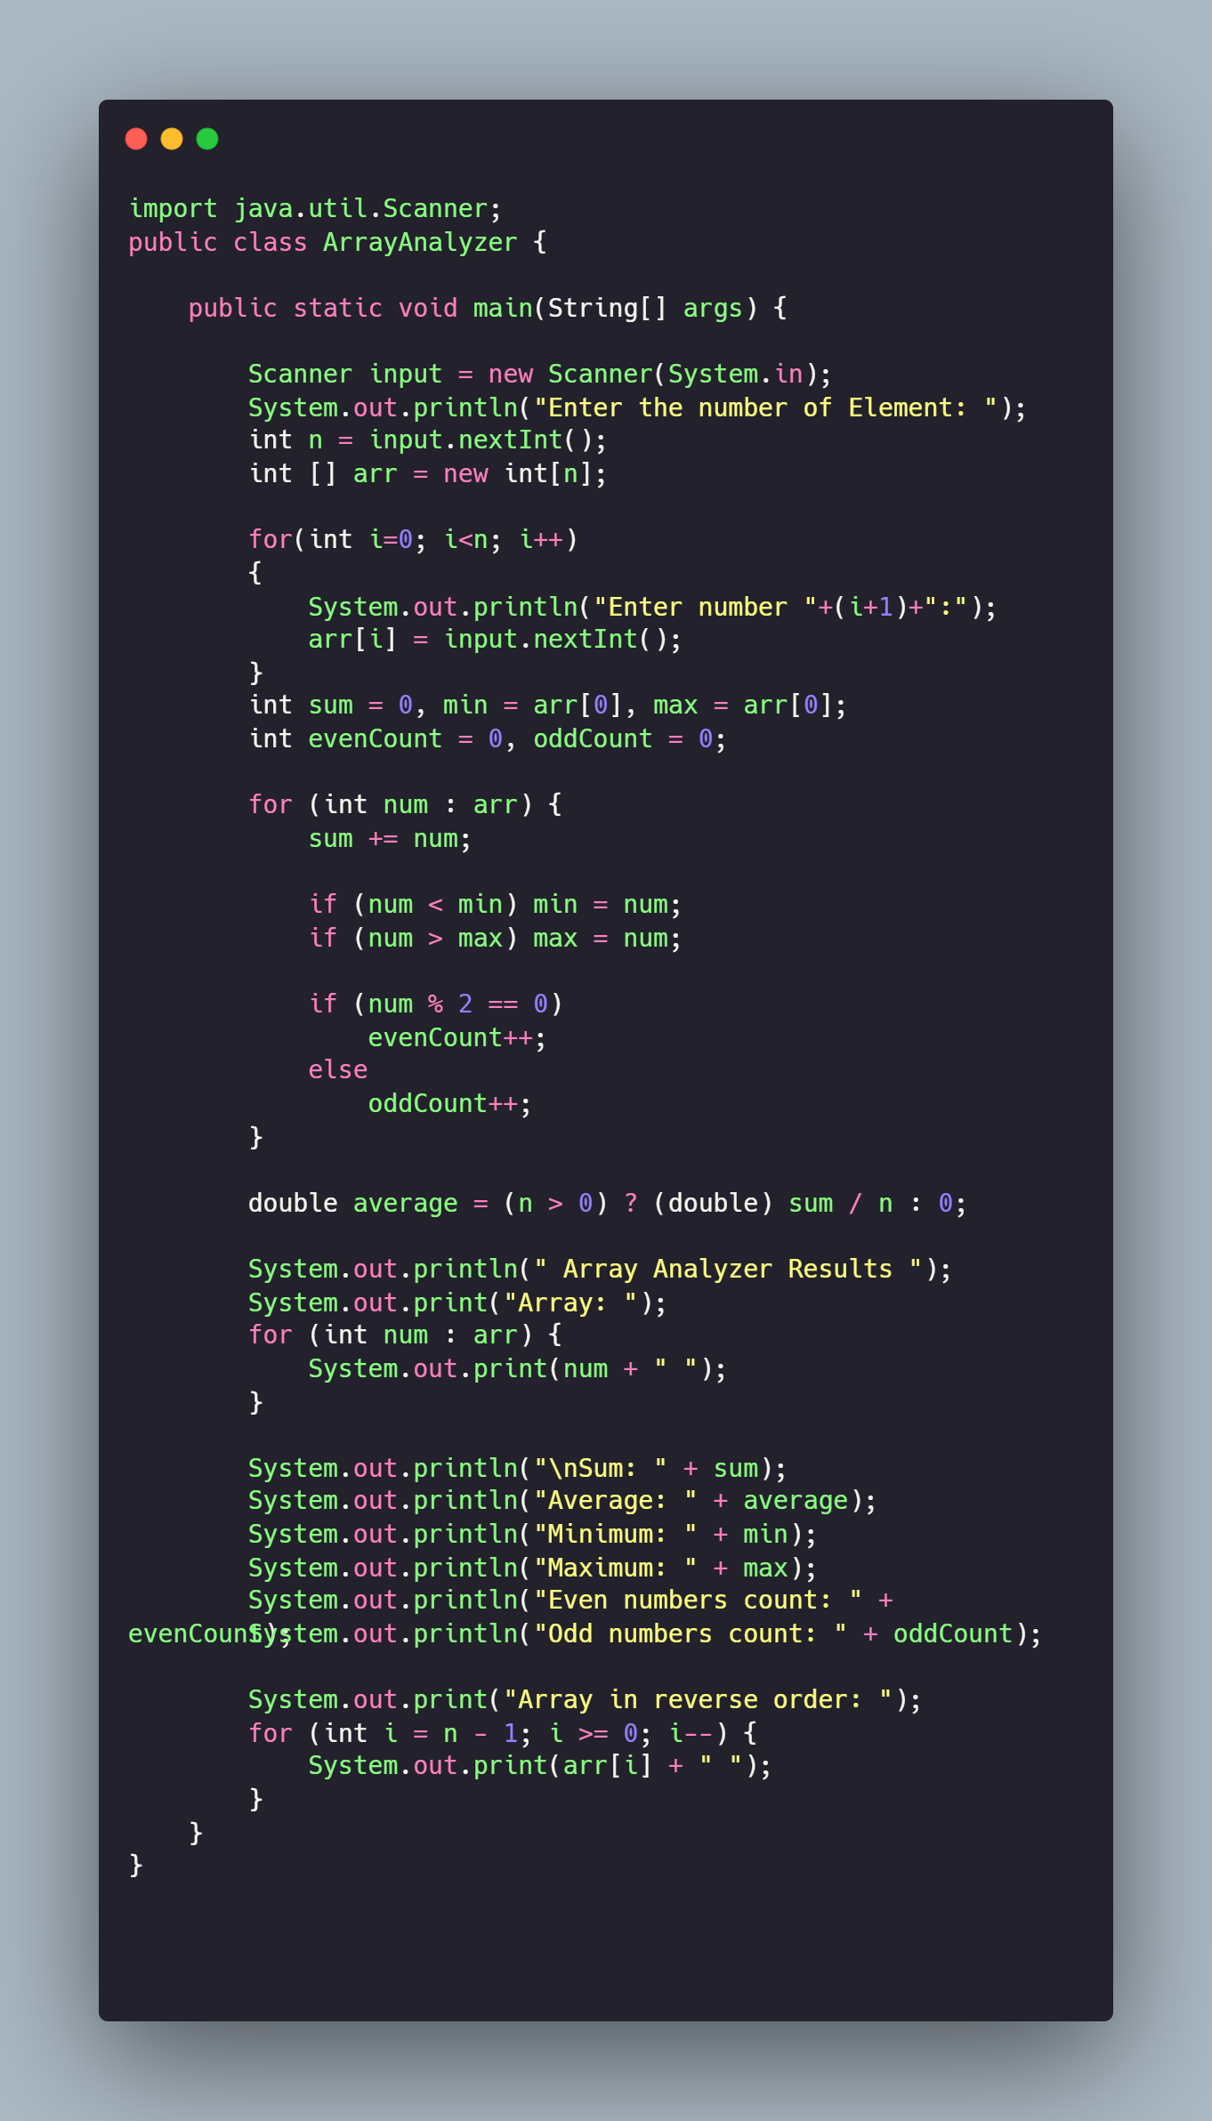
Output: 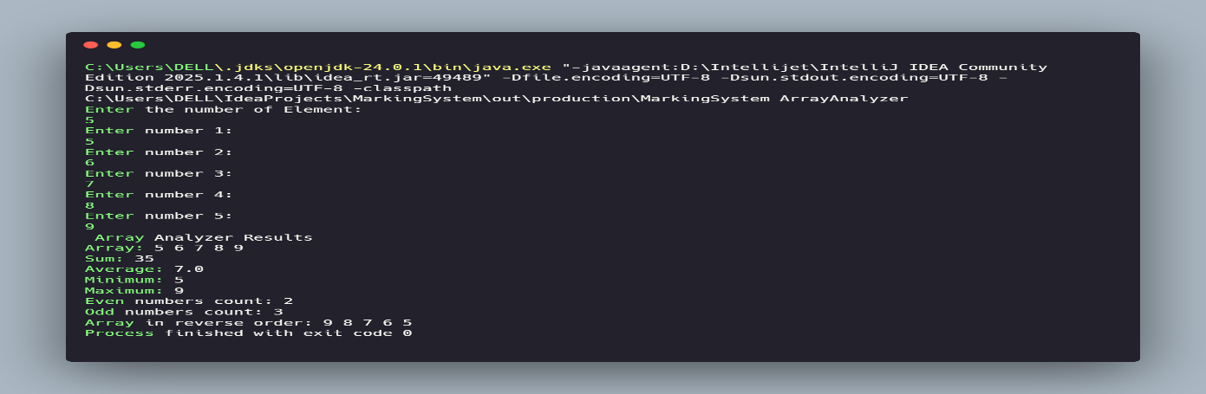
Q3: Utility Method Pack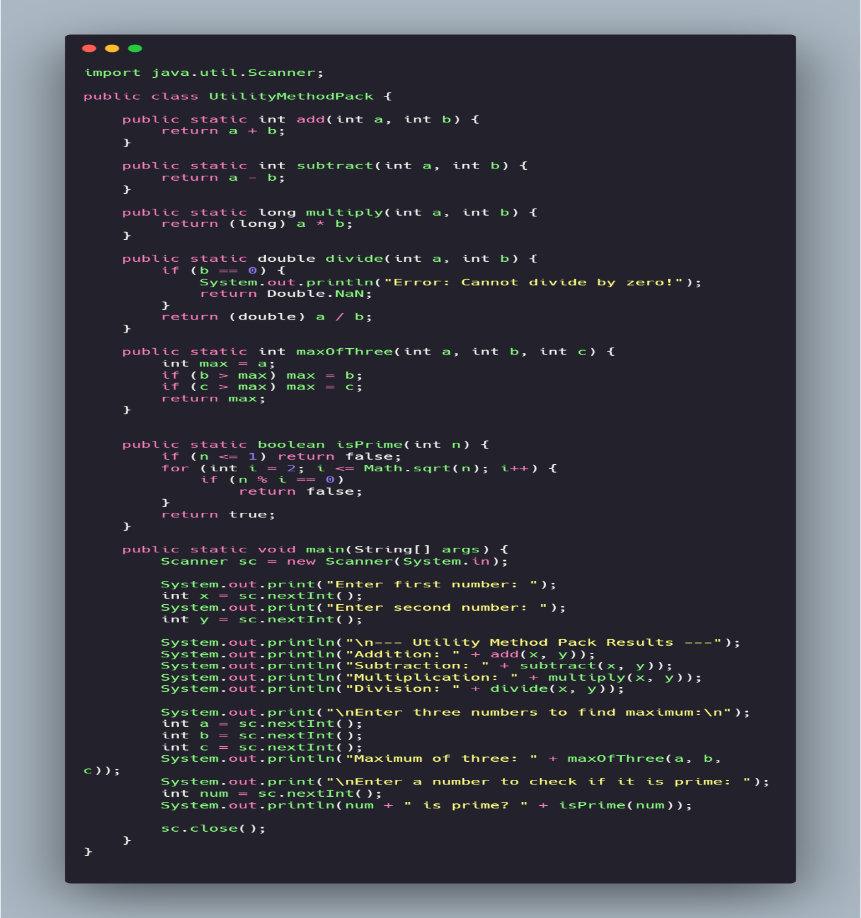
Output: 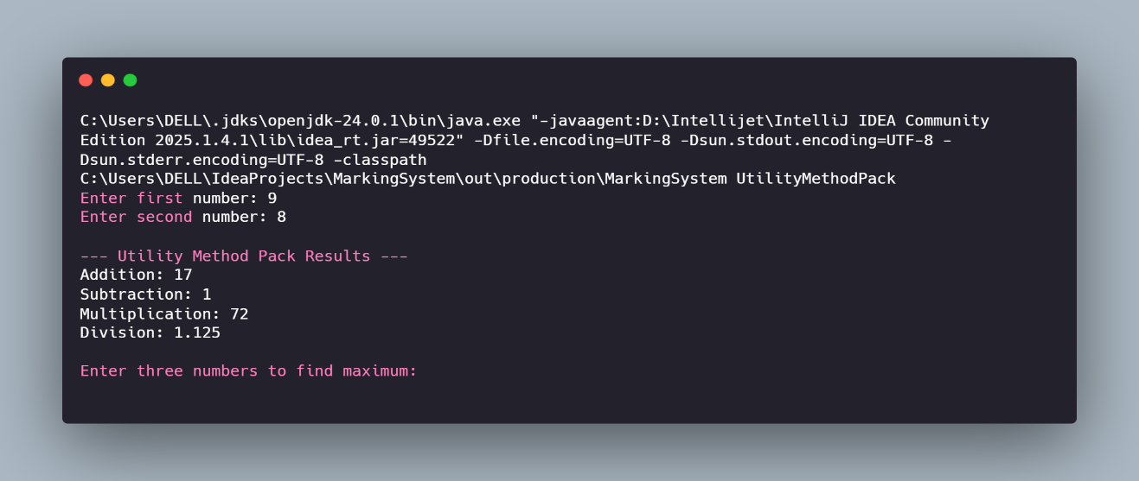
Q4: Method Overloading: Area Calculator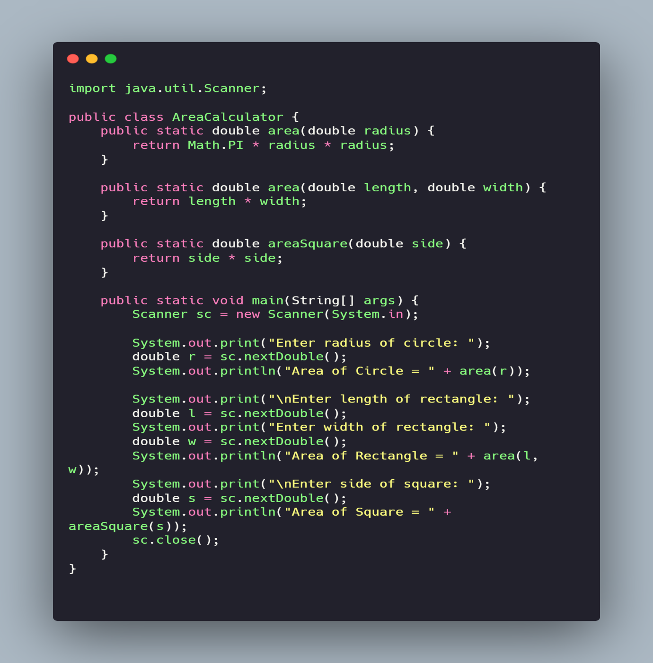
Output: 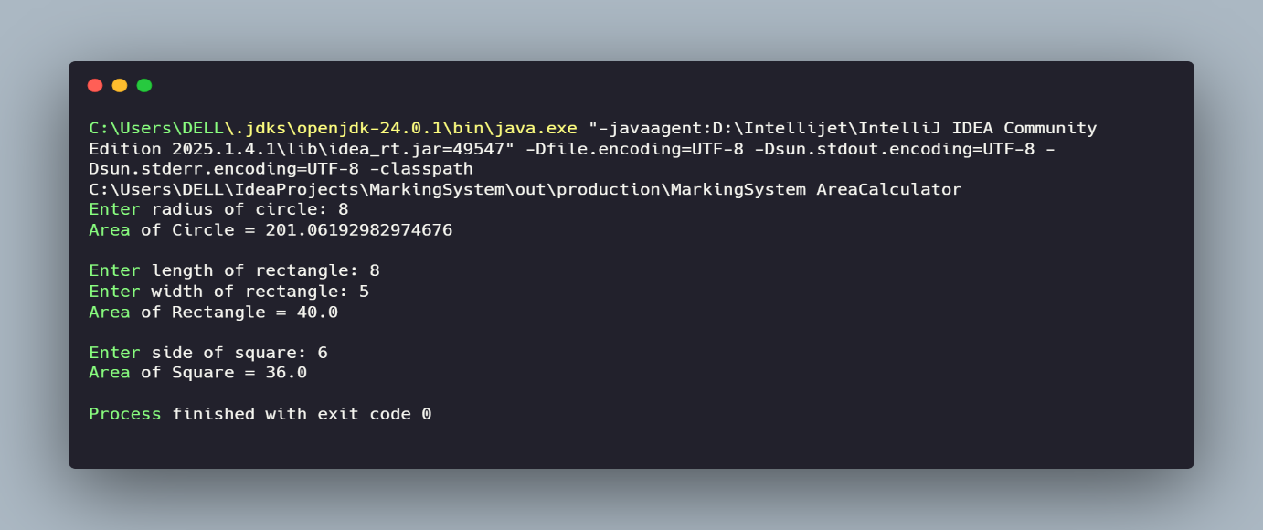
Q5: Mini Projects
Project 1: ATM Simulation System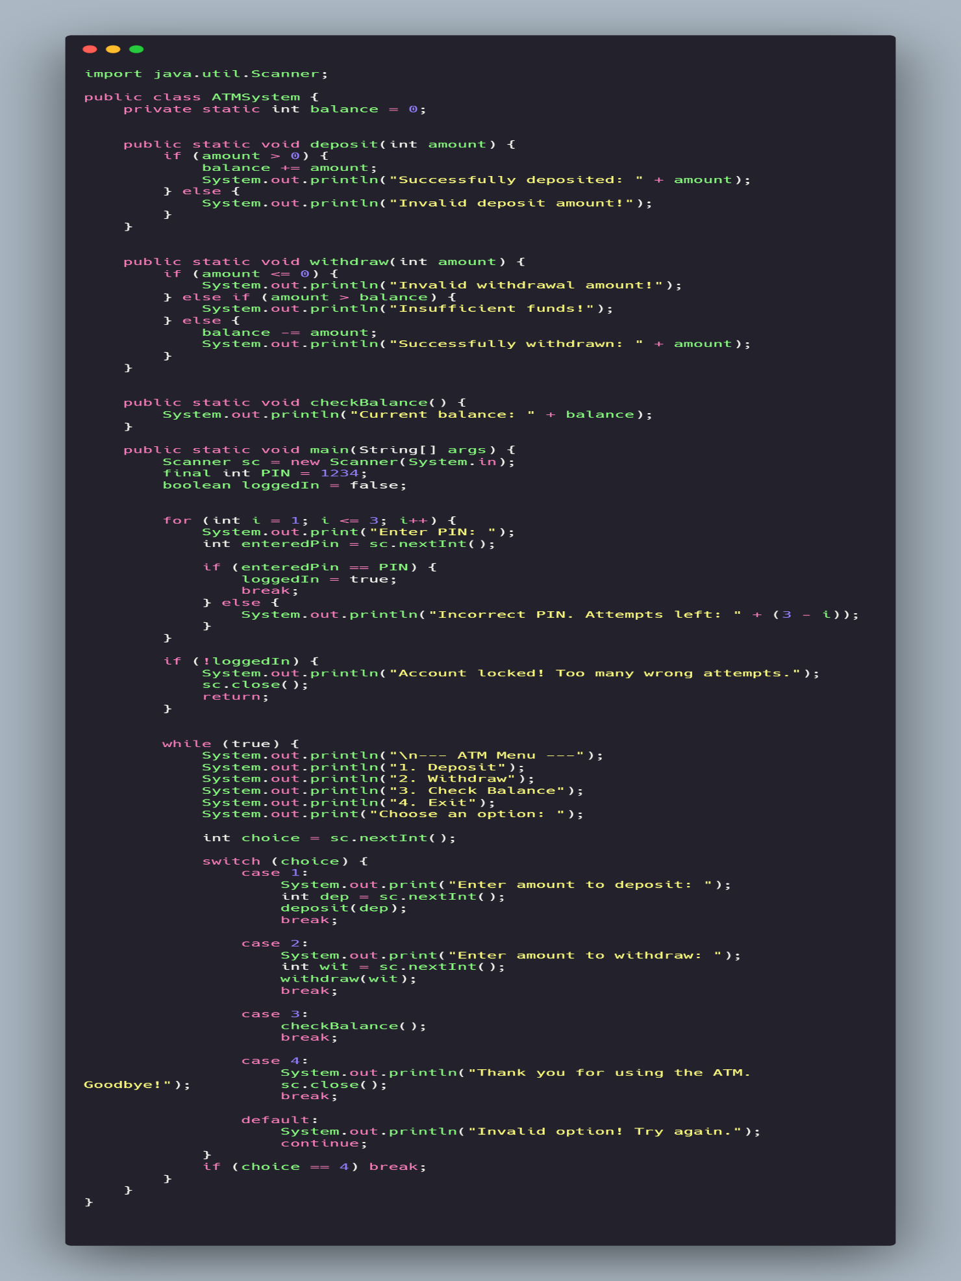
Output: 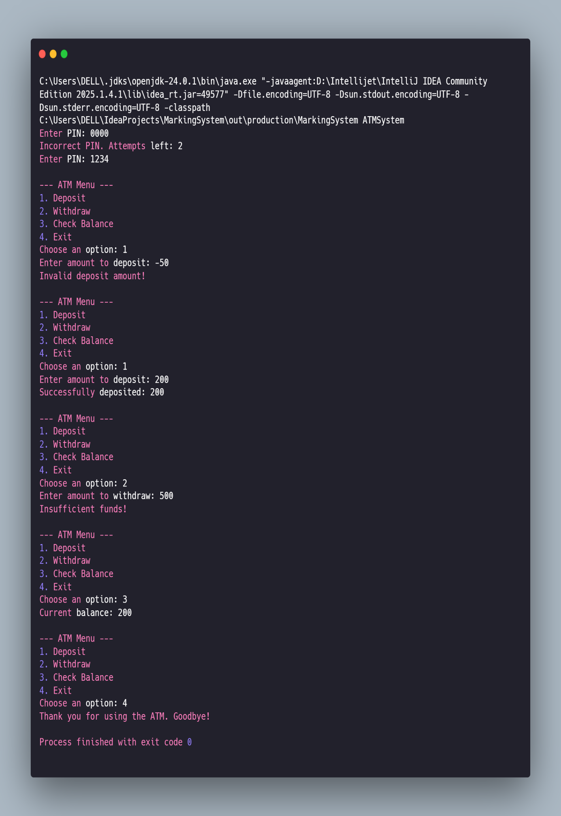
Project 2: Student Gradebook Manager: 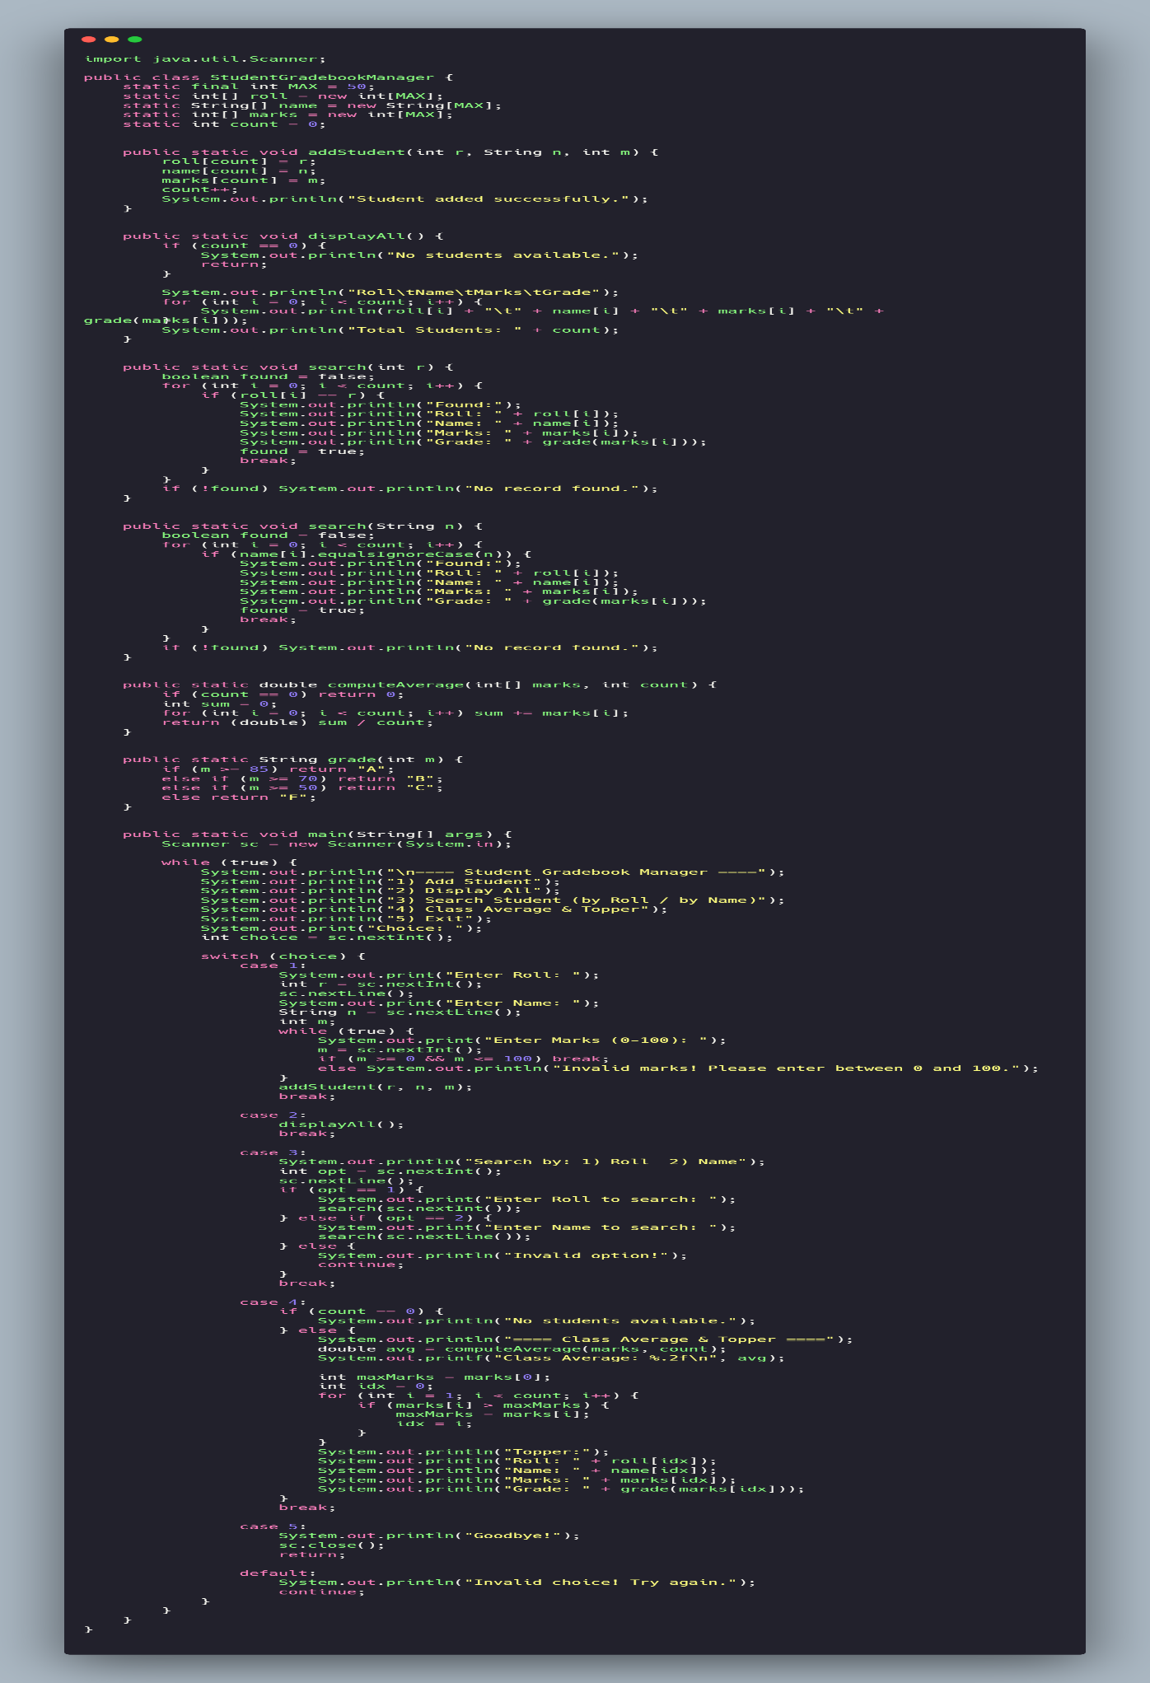
Output: 